Pedro Juan Bright Samper

Universidad Jorge Tadeo Lozano

Bogotá, Colombia

**Bermúdez Umaña, Guillermo (1924-1995)**

Colombian architect Guillermo Bermúdez was born close to Bogotá, the capital of Colombia. He started studying architecture at the Catholic University in Santiago de Chile, an academic programme based essentially on the precepts of the "Beaux Arts". When his family returned to Colombia he enrolled in the National University, a state funded liberal institution with a more modern approach to architecture. He obtained his degree in 1948.

After a brief spell as partner of DOMUS, a firm established with colleagues Francisco Pizano and Hernán Vieco, he established his own practice. In time he would work with several architects, including lifelong friend Fernando Martínez Sanabria and Rogelio Salmona. On later days the firm would include Pablo Lanzetta and Emilio Arango as associates.

His main body of work consists of single-family houses and low-rise apartment buildings, where his knowledge, expertise and taste were undoubtedly appreciated.

His work has been highlighted by several authors, especially on account to his attention to detailing and building. In his projects a certain duality within the classic and the modern seems to appear. From one point of view the idea of the free plan especially in social and public areas, where white interiors and staircases basking in light would become the key. From another, the idea that a project should be conceived and seen as a unitary whole, a more classic approach, leading to and independence between the technical solution of the roof and facades and the conception and form of interior space.

His precise design and attention to quality in construction went hand in hand with a precise knowledge and control on a house’s privacy conditions as well as a deep awareness of the different relationships between rooms and activities, personal and social, that constitute life within a house, an approach that would seem to link his projects and manner of work to the writings of Robert Kerr. His projects are characterized by an introverted experience, resulting in both a distance from the city and an enormous importance of the relationship with interior gardens.

In 1952 he built the first stage of his own house, usually know as "casa Bermúdez", adding a master bedroom and more service areas in 1957. The house won the first prize for the best residence in the first Colombian Architecture Biennial in 1962. He would be awarded the same prize for the Bravo House and a special mention for El Polo housing project designed with Rogelio Salmona in 1964. He would later win his last national architecture prize for the Alberto Lleras Camargo building in the Universidad de los Andes designed with his son, Daniel Bermúdez Samper.

Throughout his life he combined his architectural practice with his teaching activities in the design workshops in the National University, where his precise and sometimes ironic comments were both appreciated and feared.

List of works 1952-1990 (In Bogotá, Colombia, unless otherwise stated)

Single family houses

Own house, Casa Alonso, Casa Bravo, Casa Durán, Casa Valencia, Casa Saldarriaga (Medellín) ,Casa Lanzetta, Casa Vaimberg, Edificio Las Carabelas, Casa Mutis, Casa La Manuelita, Casa Ardila (Medellín)

Apartment buildings and multiple housing

Edificio Rueda, Edificio Herrmann, Conjunto residencial El Polo (With Rogelio Salmona), Edificio Embajador, Edificio Avenida 82, Edificio El Refugio, Conjunto El Cotador, Edificio El Sendero, Edificio Ponce de León

Educational and institutional buildings

Colegio Nueva Granada, Facultad de Economía – Universidad Nacional de Colombia (With Fernando Martínez), Edificio de la Bolsa de Bogotá, Colegio Anglo Colombiano, Instituto de Investigaciones Tecnológicas, Hemeroteca Nacional Universitaria – Universidad Nacional de Colombia, Edificio Alberto Lleras Camargo – Universidad de los Andes (With his son, Daniel Bermúdez Samper)

Further reading

Bright Samper, P. (2006) *La construcción de la intimidad. Casas de Guillermo Bermúdez Umaña 1952-1971.* Bogotá: Universidad Nacional de Colombia

Bright Samper, P. (2010) *Todas las casas son iguales a todas las casas, pero unas casas son más casa que otras: dos de Guillermo Bermúdez Umaña.* In Recinto. Reflexiones sobre arquitectura y ciudad. Bogotá: Universidad Jorge Tadeo Lozano

Charum, M. (2009) *Itinerario interior. El espacio doméstico en la arquitectura de Guillermo Bermúdez.* Bogotá: Universidad Nacional de Colombia

Mejía, C. (2009) Haute couture - *Pret à porter. Edificios de apartamentos de Guillermo Bermúez.* Bogotá: Universidad Nacional de Colombia

Montenegro, F. & Niño Murcia, C. (1980) *La vivienda de Guillermo Bermúdez.* Bogotá: Escala

Samper, E. (2000) *Arquitectura moderna en Colombia: época de oro.* Bogotá: Diego Samper Ediciones

Weiss Salas, Philip (2008) *1+1+2=uno. Forma y figura en el edificio Herrmann de Guillermo Bermúdez.* Bogotá: Universidad Nacional de Colombia

Links

http://dearq.uniandes.edu.co/articles/2011/la-casa-berm-dez-samper-1952-1960-bogot-colombia

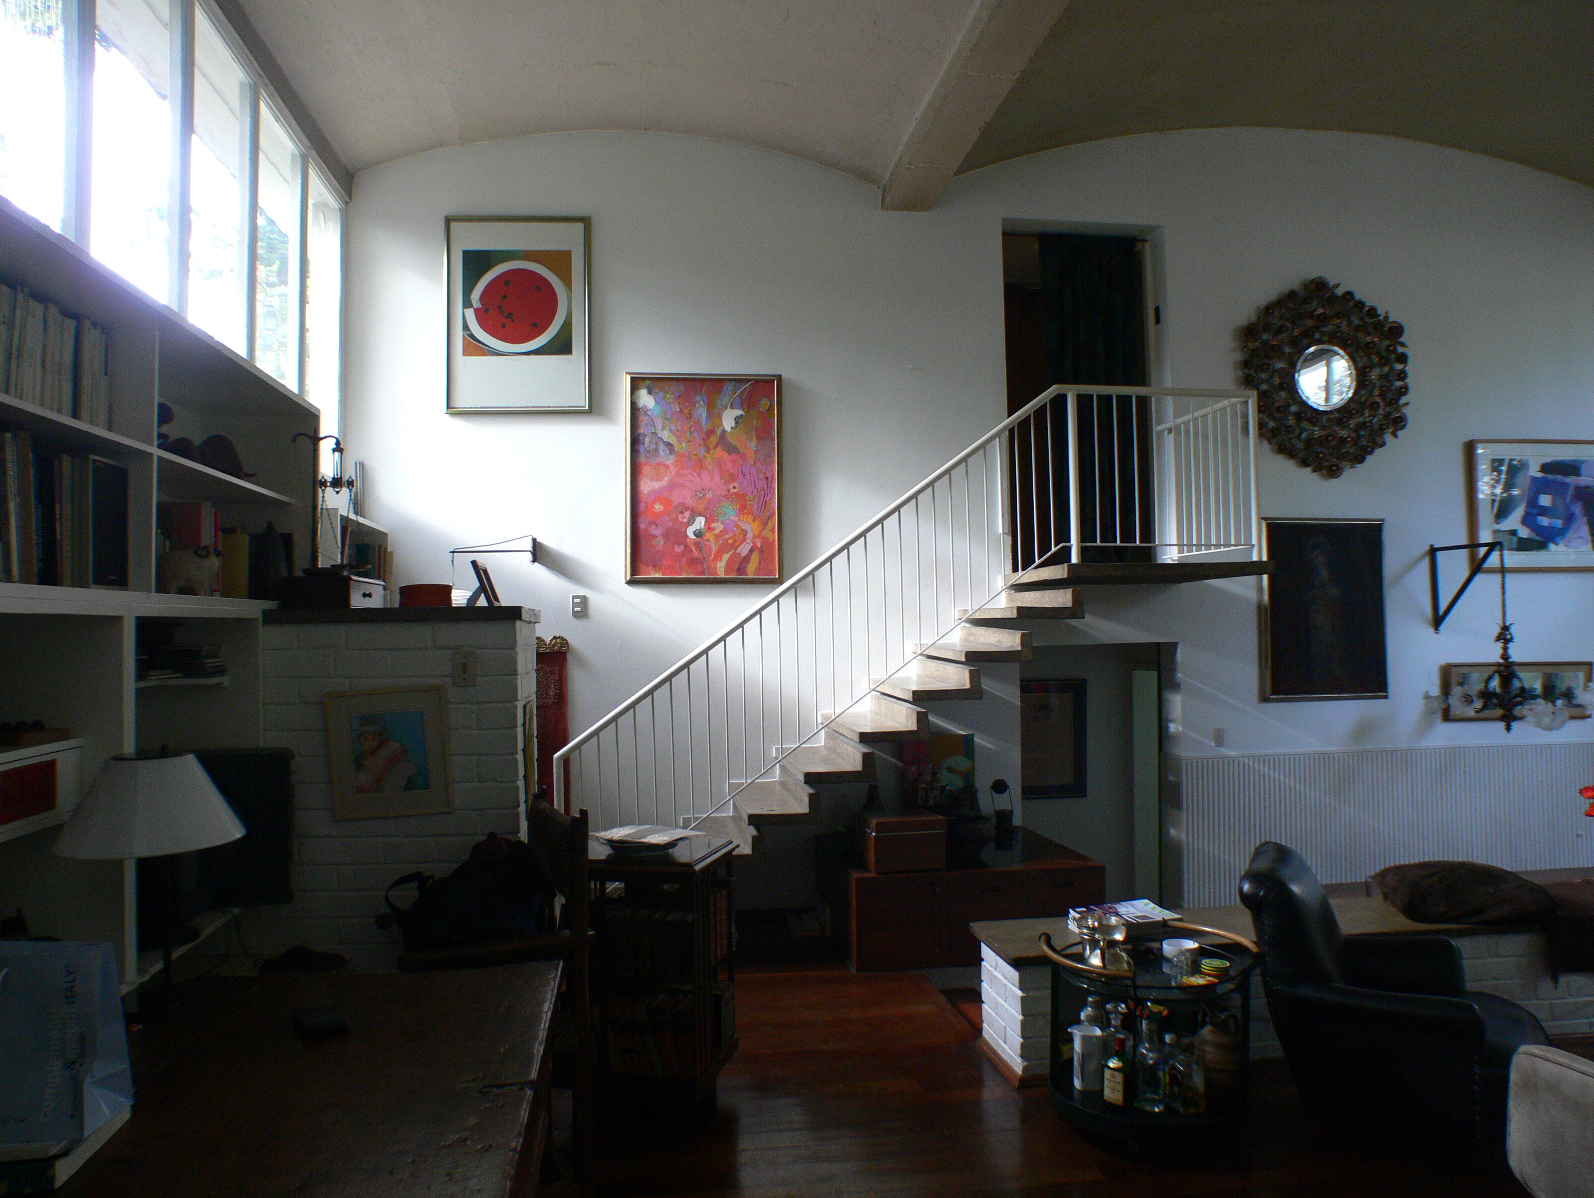

Casa Bermúdez. Photo Peter Bright

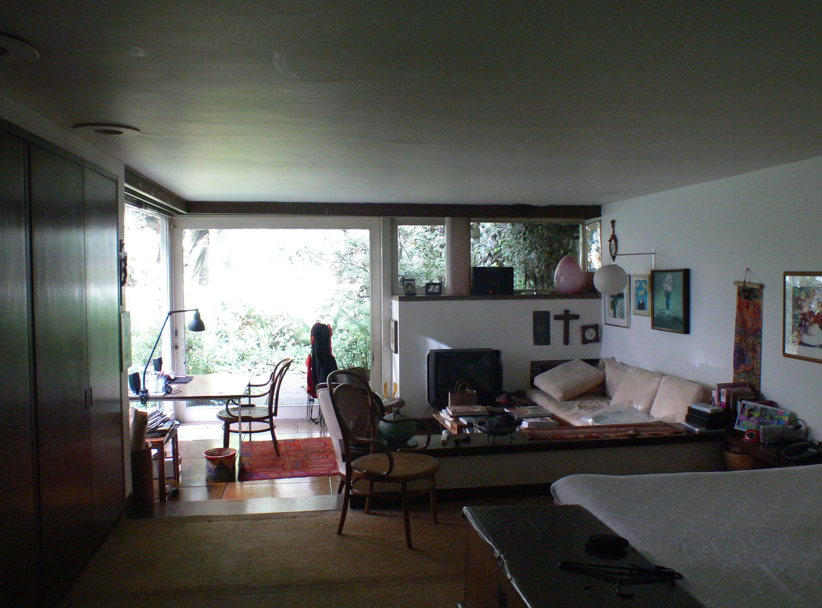

Casa Bermúdez. Photo Peter Bright